Assignment 3 Group Report

SIT216: USER CENTERED DESIGN

Group 8:​​

Deon Salil Payyappilly​

Mohamad Zhafran Athaillah​​

Peter Dao​

Table of Contents

Introduction 3

Functionality 4

Justification 6

User Testing methods 12

References 13

# Introduction

Tired of find contacts for any home improvement services at your region! You don't need to search them, because we have them all here.

This app will generate a list of contact for home improvement services on your selected region, then you can contact them right away. It also recommends you the right services on the specific house parts that you need to improve. Electricity, painting, plumbing? We have it all. For each selection the app will give you a list of recommended services with their details, so you can contact them right away.

# Functionality

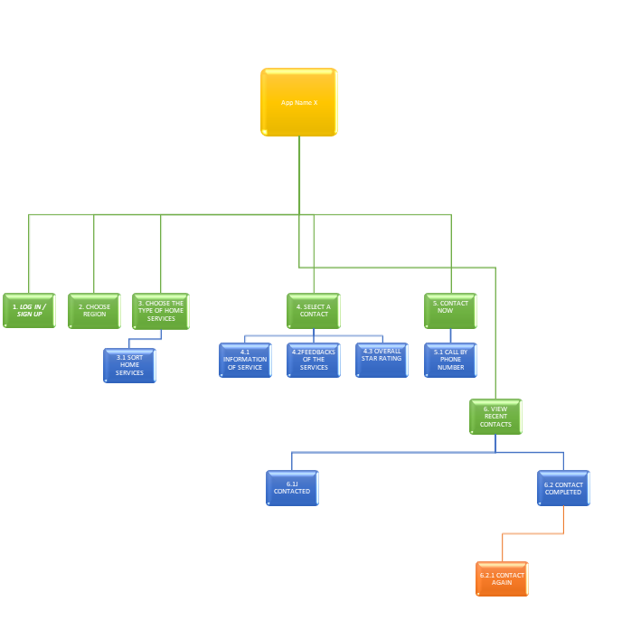

Functionality Storyboard:

* Step 1: - Login / Signup (The user needs to create an account for “Home service”or may need to sign in with existing account) To make it simple the app provides user to login account with google id or Facebook ID.
* Step 2: - user need to choose the region where he /she lives so that “Home service” can filter and sort out the services that is only nearby to give out effective services. It functions a drop-down menu bar for easier location searching.
* Step 3: - After that, the user is able to choose between the services which the app provides (Example: - Electricity, Plumbing, Painting, Innovation etc.) if the user has a problem with their sink for example, he can choose the plumbing menu.
  + 3.1: - The sort button at the top right of corner helps user to sort services according to his/her preferences. Thus, they can choose the product easily. This features a drop-down menu option that lets user choose from highest to lowest prices and even lowest to highest ratings.
* Step 4: - when the user chooses the service, then the user will be taken to other screen showing the contacts list about services available nearby with all the required info like feedback rating, contact number, photo and price. Users are able to scroll down depending on the number of contacts available
  + 4.1: - Gives out description of the selected service that the user needs to know before contacting services.
  + 4.2: - Shows varies feedback given by plethora of users who have had the service before.
  + 4.3: - Overall star rating of the services will be given on the scale of Five.
* Step 5: - At the side the user can click contact now which the app takes directly to the Dialpad off the phone which the number of the contact is already be copied to Dialpad.
* Step 6: - These option shows out the recent contact which the user made earlier and now.
  + 6.1: - Contacted: - shows the data of contacts that user contacted for the service but hasn’t completed the entire service.
  + 6.2: shows the history of completed contacts and with the option to provide contact again allows the user to contact again the completed services.

# Justification

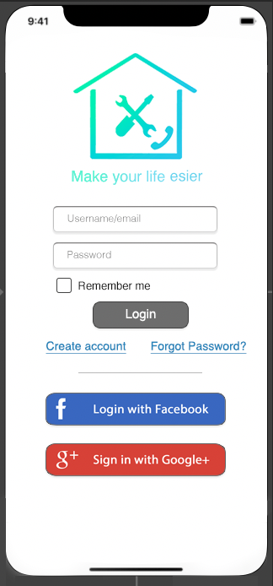

Starting from the login screen, the display is pretty similar to any other mobile application login screens. Letting the user enter their username and password to login also the option to use Facebook or Google logins with their natural color (blue for Facebook and red for Google). We added the create account for sign ups and forgot password feature just in case, and both are represented as a link to indicate the buttons.

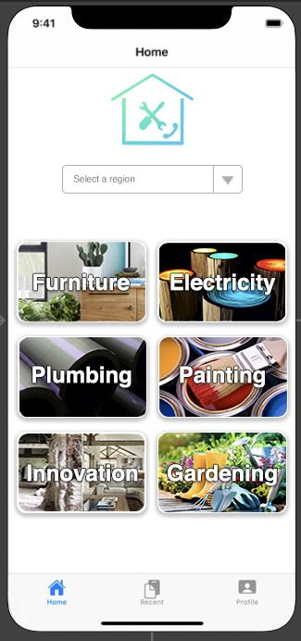

On the main screen we have provided a navigation bar at the bottom of the screen which is common to mobile app interface standards. The select region features a drop-down search bar which is also used in many apps nowadays to search for a location or address. We manage to use pictures for the buttons with the names on them since icons might lead to confusion also, they won’t look good if they are oversized so instead, we use names with background pictures as the button since they will be the main focus of this page and with larger sizes making them easier to select without selection mistakes.

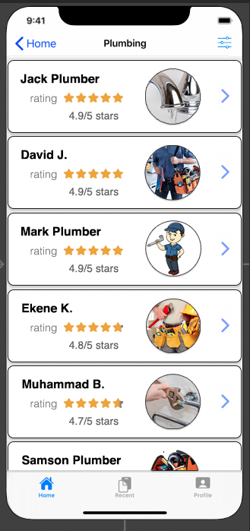

The above screen is the contact screen. It shows short information of the contact that the user wants to get in touch. The details of the contact will be expanded once the user click on the arrow pointing right words. At the top right corner there is three parallel line with small dots is the filter button which filter the contact according to user needs

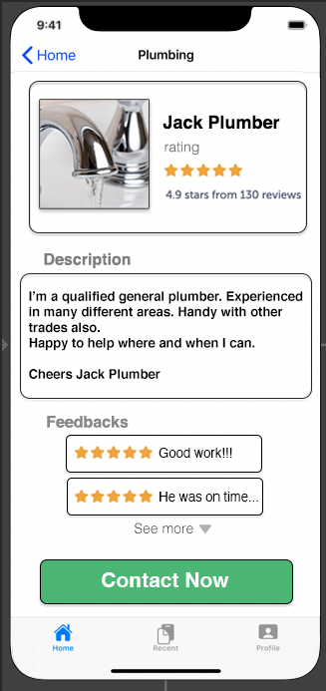

The above screens provide a detailed information about the contact at top of the screen the name of service that user choose and just below of that shows the Name of the contact and rating on a scale of 5 stars. The description is mainly written by the servicer about the qualification, experience that he/she got throughout the life. Feedback feature allows the user to open and point out about the service they experienced. At least, Contact now will take the user to Dialpad giving all details contact that service. Each of the information are provided in a box like display in order to present an easy to read environment by separating them into boxes. While the contact now features a green colored box to indicate a button that is the main function of the page.

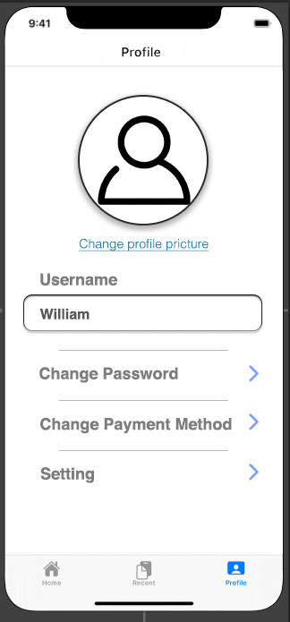

Once the user clicks the profile tab on the navigation bar the above screen will be shows. Profile screen is mainly used to edit personal data. The user can change the profile picture by clicking Change profile picture. At the last setting is used organize notification, theme of the app, sounds, payment etcetera.

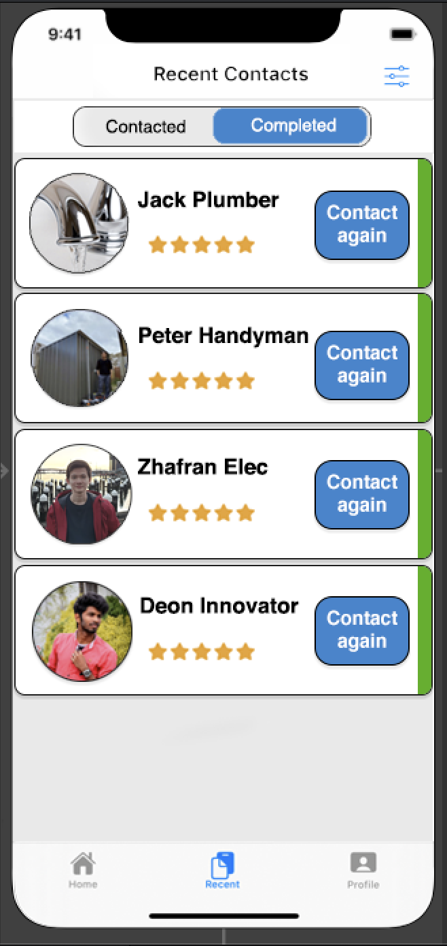

The recent tab shows the data of the services which is contacted recently. It is divided onto 2 sections: -

* Contacted: - Services which the user connected for current issue
* Completed: - Services which completed

The different between each tab is completed tab shows the user feedback and contact again but the contacted tab just shows option to contact again only.

# User Testing methods

## User testing Report

To get the feedback and user evaluation the apps will firstly be introduced as a free trial to various people in different regions. At 1st our volunteer went to specific village and introduced the Home and showed how the app works. They will be given a chance to use the app so that they will get to know about all features and how things work. After that they will be asked to do a simple task to contact one of the available home services at their regions.

For making User report and Improvement the Following survey questions will be asked to the testers.

* Do you think the app is easy to understand?
* Can you describe a situation which “Home service”is useful?
* Can the app solve your problem?

# References

References

Allen, J, n.d., *Creating APIs in R with Plumber*, image, retrieved 2 Jun 2020, < https://www.rplumber.io/docs/>.

Bay Wood Plumbing and Gas n.d., *Plumber Perth - Your Reliable & Affordable Perth Plumber*, photograph, retrieved 2 Jun 2020, <https://baywoodplumbingandgas.com.au/>.

Capital Plumbing LLC, 2015, *Cover photo*, photograph, retrieved 31 May 2020, <https://scontent.fmel3-1.fna.fbcdn.net/v/t31.0-8/12002398_1189437354419370_5919289953652197974_o.jpg?_nc_cat=101&_nc_sid=e3f864&_nc_ohc=EzVdT5jSrboAX8GDcjN&_nc_ht=scontent.fmel3-1.fna&oh=3d4995c7820c82c7c7c3a35f265b5fd2&oe=5EFD25A7>.

Edwards, P, 2019, *Hamilton Plumber: How to Turn off the Water for Plumbing Repairs*, image, retrieved 2 Jun 2020, <https://greatshroudofturinfaq.com/hamilton-plumber-how-to-turn-off-the-water-for-plumbing-repairs/>.

Focuson Funiture n.d., *Furniture Collection*, photograph, retrieved 28 May 2020, <https://www.focusonfurniture.com.au/>.

GordonJ86 2019, *Plastic Pipe lengths manufactured in Australia by Extruding HDPE material*, image, retrieved 28 May 2020, < https://upload.wikimedia.org/wikipedia/commons/thumb/c/ca/Polyethylene_Pipe_lengths.jpg/1280px-Polyethylene_Pipe_lengths.jpg>.

HK1998, 2016, *customize Google Plus Sign in Button And Facebook Login Button*, image, retrieved 2 June 2020, <https://stackoverflow.com/questions/34305645/customize-google-plus-sign-in-button-and-facebook-login-button>.

Howard, B C, n.d., *How to Start an Organic Garden in 9 Easy Steps*, image, retrieved 28 May 2020, < https://www.goodhousekeeping.com/home/gardening/advice/g2104/organic-gardening-tips-460309/>.

Iconfinder, n.d., *Account friend human man member person profile user users icon*, image, retrieved 2 Jun 2020, <https://www.iconfinder.com/icons/392531/account_friend_human_man_member_person_profile_user_users_icon>.

Manufacturers Monthly 2018, *Australia’s largest paint factory opens in Victoria*, image, retrieved 28 May 2020, < https://www.manmonthly.com.au/wp-content/uploads/2018/05/website16_paint_cans_iStock_23034199_MEDIUM.jpg>.

O'Donnell, D, 2017, *Coach house transformation - before and after*, photograph, retrieved 28 May 2020, < https://www.irishtimes.com/life-and-style/homes-and-property/interiors/coach-house-transformation-before-and-after-1.3229138>.

Rockhampton Plumber n.d., *Plumbing and Gas Services Rockhamton*, image, retrieved 2 Jun 2020, <https://lh5.googleusercontent.com/proxy/lJjq0Ah0Kczkth5QZNMPezvUV3uMlqRfUIb5Oe_eOlh6kN8ZSEOGoT6kdMFX9z9iDbUHdFoMuuWsMYnhvootcWF-i8oczJVXazHUazNGM90-g_y5zItV5Z_iKcDauzslrnLMZDqfxA>.

Service Central Articles 2014, *Glow-in-the-dark log stools*, image, retrieved 28 May 2020, < https://www.servicecentral.com.au/article/10-adorable-uses-for-outdoor-paint/>.

Sun-Tan, C, 2018, *What to Repair Before You Sell: Plumbers with 150 Years of Experience Combined Weigh In*, image, retrieved 2 Jun 2020, < https://www.homelight.com/blog/find-plumbers/>.